**Tesco Toastie White Bread Thick 800G**

**INGREDIENTS:** Wheat Flour [**Wheat** Flour, Calcium Carbonate, Iron, Niacin, Thiamin], Water, Yeast, Salt, Preservative (Calcium Propionate), **Soya** Flour, Emulsifier (Mono- and Di-Acetyl Tartaric Acid Esters of Mono- and Di-Glycerides of Fatty Acids), Spirit Vinegar, Rapeseed Oil, Flour Treatment Agent (Ascorbic Acid).

**Allergy Information**

For allergens, including cereals containing gluten, see ingredients in bold.

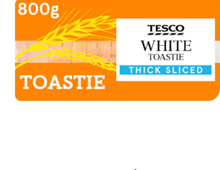

**ASDA Choco Snaps Cereal**

Ingredients

Rice, Sugar, **Milk** Chocolate (6%) [Sugar, Cocoa Mass, Whole **Milk** Powder, Cocoa Butter, Whey Powder (**Milk**), Skimmed **Milk** Powder, Emulsifier (**Soya** Lecithins), Flavouring], Fat Reduced Cocoa Powder, Calcium Carbonate, Dextrose, Salt, **Barley** Malt Extract, Flavourings, Vitamin and Mineral Mix [Iron, Niacin (B3), Pantothenic Acid (B5), Thiamin (B1), Riboflavin (B2), Vitamin B6, Folic Acid (B9), Vitamin D, Vitamin B12]

For allergens, see ingredients in bold.

Allergy Advice **Contains: Barley, Milk, Soya.**

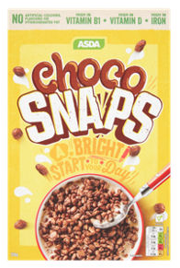

**ASDA No Added Sugar Double Strength Strawberry Squash**

Allergy Advice

**Contains: Sulphur Dioxide/Sulphites.**

Ingredients

Water, Strawberry Juice from Concentrate (24%), Citric Acid, Malic Acid, Acidity Regulator (Sodium Citrates), Flavouring, Sweeteners (Acesulfame K, Sucralose), Plant and Vegetable Concentrates [Black Carrot, Hibiscus], Preservatives (Potassium Sorbate, Sodium **Metabisulphite**), Antioxidant (Ascorbic Acid)

For allergens, see ingredients in bold.

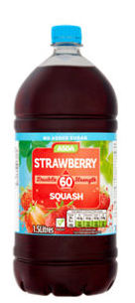

**Flora Original Spread 500G**

Ingredients

Plant Oils (Rapeseed, Palm*, Sunflower 3%, Linseed), Water, Salt 1.35%, Plant Based Emulsifier (Sunflower Lecithin), Fava Bean Protein, Natural Flavourings, Vitamins A and D, *Flora buys 100% Sustainable Palm Oil

